**Auto Assign SKU to Category when PO Imported**

Taki Guan

# Version History

|  |  |  |  |
| --- | --- | --- | --- |
| Version | Author | Date | Changes |
| 1.0 | Taki Guan | 2019-5-7 | Create Document |
| 1.0 | Taki Guan | 2019-5-13 | Finish Document |
|  |  |  |  |
|  |  |  |  |
|  |  |  |  |
|  |  |  |  |

Contents

Version History 1

Purpose 1

Procedure 1

Architecture 2

Reference Link 4

# Purpose

This function is designed by Yahua to help auto assign items to specific category. It starts from work order import into [ngsfr_subr_production_order]. Then it will trigger store procedure [ngsfr_Intf_ItemProcessLink_Upd]. Store procedure [sp_I_Item_Category_Link] will be called here.

# Procedure

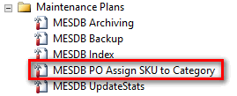

Here a maintenance plan created every 15 min to run store procedure [ngsfr_Intf_AssignCat4PO].

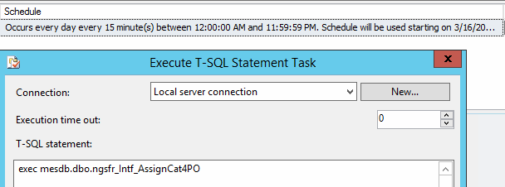

# Architecture

**[ngsfr_Intf_AssignCat4PO]**

ALTER PROCEDURE [dbo].[ngsfr_Intf_AssignCat4PO]

AS

BEGIN

    SET NOCOUNT ON;

    SET XACT_ABORT ON;

declare @curRecID int

    declare myCsr cursor for select top 50 intf_record_id from ngsfr_subr_production_order spo where spo.intf_process_status=5

    and not exists (select 1 from ngsfr_PO_AssignedCategory ps where ps.intf_record_id=spo.intf_record_id)

    order by intf_record_id

    open myCsr

    fetch next from myCsr into @curRecID

    while @@FETCH_STATUS=0

    begin

        exec ngsfr_Intf_ItemProcessLink_Upd @curRecID

        fetch next from myCsr into @curRecID

    end

    close myCsr

    deallocate myCsr

END

Here a temp table [ngsfr_PO_AssignedCategory] is created to store [intf_record_id] processed.

**[ngsfr_subr_production_order]**

ALTER PROCEDURE [dbo].[ngsfr_Intf_ItemProcessLink_Upd](@varRecID int)

AS

BEGIN

    SET NOCOUNT ON;

    SET XACT_ABORT ON;

*--UPDATE ngsfr_subr_production_order SET intf_process_status = 2 WHERE intf_record_id = @varRecID*

    if not exists (select 1 from ngsfr_PO_AssignedCategory where intf_record_id=@varRecID)

    begin

        insert into ngsfr_PO_AssignedCategory(intf_record_id) values(@varRecID)

    end

*--Assign SKU to Category*

    declare @curItem nvarchar(20),@curLineType nvarchar(40)

    select top 1 @curItem=material,@curLineType=work_center

    from ngsfr_subr_production_order where intf_record_id=@varRecID

    if @curLineType is not null and @curItem is not null

    begin

        declare @tb table(category_id int,category_name nvarchar(100),LineType nvarchar(20),CateType nvarchar(20),curLineType nvarchar(40),actionFlag int)

        insert into @tb(category_id,category_name,LineType,CateType,actionFlag)

        select ct.category_id,ct.category_name,p.Value as LineType,ct.spare2 CateType,0

        from category ct cross apply dbo.ngsfr_fn_S_Split_String(ct.spare1,',',1) as p

        where spare1 is not null and spare2 is not null

*--*

        update @tb set curLineType=@curLineType

        update @tb set actionFlag=1 where curLineType like LineType+'%' and CateType='COMMON'

        update tmp set actionFlag=2

        from @tb tmp,item_category_link icl

        where tmp.actionFlag=1 and tmp.category_id=icl.category_id and icl.item_id=@curItem

*--*

        declare updCsr cursor for select category_id from @tb where actionFlag=1

        declare @curCateID int

        open updCsr

        fetch next from updCsr into @curCateID

        while @@FETCH_STATUS=0

        begin

            begin try

                exec sp_I_Item_Category_Link @curCateID,@curItem,null,null

            end try

            begin catch

            end catch

            fetch next from updCsr into @curCateID

        end

        close updCsr

        deallocate updCsr

    end

END

Here you can see Yahua insert [intf_record_id] to [ngsfr_PO_AssignedCategory] at first. Then create a temp table @tb to store the category need to be inserted.

Here [actionFlag] is used to identify if the item is maintained or not. If equal to 1, this item needs to be maintained use store procedure [sp_I_Item_Category_Link]. Else if the value is 2, it has been maintained already.

# Reference Link